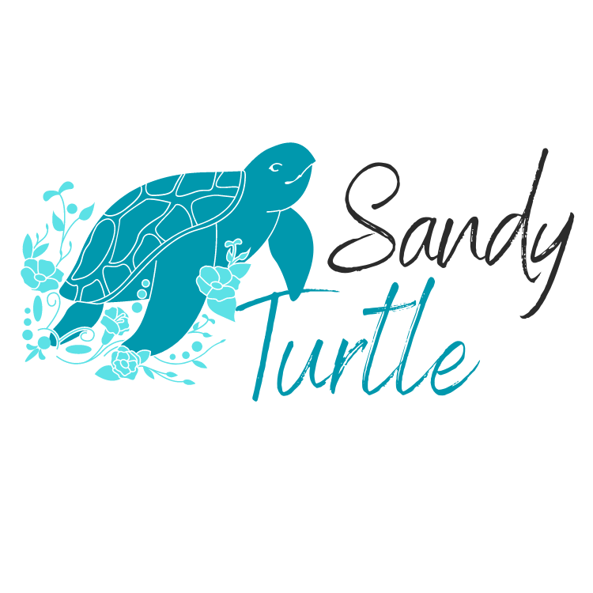
- Introduction
  - Purpose
The purpose of this policy at Sandy Turtle Supports and Therapies is to establish comprehensive risk management practices to safeguard the health and well-being of all our stakeholders, including Workers, volunteers, and participants. This policy guides us in complying with health and safety legislation, identifying and managing potential risks, creating a hazard-free work environment, and providing high-quality support. It reinforces our dedication to continuous improvement, Worker training, stakeholder engagement in decision-making processes, and implementation of proper insurance measures.

  - Scope
This Policy is applicable to all Workers affiliated with Sandy Turtle Supports and Therapies. It is the responsibility of every individual, regardless of their employment status, to fully comprehend and comply with the commitments outlined in this policy. All Workers must acknowledge that they have read, understood and will comply with the contents of this Policy.

  - NDIS Indicators (Objectives)
In alignment with our commitment, Sandy Turtle Supports and Therapies endeavours to demonstrate the following quality indicators by implementing and adhering to this policy and other related documentation.
Risk Management
Outcome: Risks to participants, workers and the provider are identified and managed.
To achieve this outcome, the following indicators should be demonstrated:
- Risks to the organisation, including risks to participants, financial and work health and safety
risks, and risks associated with provision of supports are identified, analysed, prioritised and
treated.
- A documented risk management system that effectively manages identified risks is in place and is relevant and proportionate to the size and scale of the provider and the scope and complexity of supports provided.
- The risk management system covers each of the following:
    - Incident management
    - Complaints management and resolution
    - Financial management
    - Governance and operational management
    - Human resource management
    - Information management
    - Work health and safety, and
    - Emergency and disaster management.
- Where relevant, the risk management system includes measures for the prevention and control of infections and outbreaks.
- Supports and services are provided in a way that is consistent with the risk management system.
- Appropriate insurance is in place, including professional indemnity, public liability and accident insurance.

- Policy Statement
- Sandy Turtle Supports and Therapies is deeply committed to the health, safety, and well-being of all our Workers, volunteers, Participants, and visitors. It is our policy to provide a work environment that is free from hazards, accidents, and incidents that could harm individuals or disrupt our ability to provide high-quality support and care.
- Our commitment extends to ensuring that our operations and practices are conducted in a manner that prevents injury and illness. This is achieved by adhering to current health and safety legislation and relevant industry standards.
- We believe that a safe and healthy work environment is a shared responsibility. This means that everyone from management to Workers, including volunteers and contractors, is responsible for their own safety and for the safety of those around them.
- To uphold this commitment, we will:
    - Develop, implement, and review a comprehensive and effective health and safety management system.
    - Regularly assess risks and take necessary steps to eliminate or control hazards that may cause injury or illness.
    - Provide education and training to all Workers to ensure they understand their health and safety obligations and how to safely perform their roles.
    - Involve Workers, volunteers, and contractors in the decision-making processes through regular consultation on health and safety matters.
    - Implement continuous improvement strategies to better our health and safety performance, including reviewing and learning from incidents and near misses.
    - Maintain a supportive culture that encourages active participation and cooperation of all Workers, Participants, and visitors in promoting and developing measures to ensure health and safety at work.

  - Relevant legislation
All relevant legislation to this Policy is outlined in the Legislation Register.

  - Related documents
- Model Code of Practice: How to manage work health and safety risks
- Home Risk Assessment Checklist
- Hazard Identification Checklist
- WHS Risk Management Matrix
- Risk Management Policy

- Responsibilities and Roles
  - Sandy Turtle Supports and Therapies Responsibilities
In accordance with regulatory requirements, Sandy Turtle Supports and Therapies recognises its duty to ensure the health and safety of all Workers, volunteers, contractors, Participants, and visitors in our care environment. In fulfilling this obligation, we will make every reasonable effort to provide and maintain a safe and healthy work environment, and to monitor the health and safety conditions of the workplace. Our specific responsibilities include:
- Providing and maintaining equipment and systems of work that are safe, reliable, and pose no health risks, as far as is reasonably practicable.
- Establishing procedures to ensure, as far as is reasonably practicable, the safe handling, use, storage, and transport of plant and substances.
- Maintaining, as far as is reasonably practicable, each workplace under our management and control in a condition that is safe and without health risks.
- Fostering a respectful, inclusive work environment for all Workers, volunteers, Participants and visitors, with a zero tolerance approach towards workplace bullying.
- Providing, as far as is reasonably practicable, adequate facilities for the welfare of our Workers at all workplaces under our control.
- Providing the necessary information, instruction, training, and supervision to all our Workers to enable them to work safely and without risks to their health.
- Monitoring the health of our Workers and the conditions of our workplace, as far as is reasonably practicable, to detect any potential health and safety risks.
- Providing relevant health and safety information in appropriate languages and ensuring that Workers know to whom they can direct inquiries or complaints about health and safety matters.
- So far as is reasonably practicable, consulting with workers who are or are likely to be directly affected by any Workplace hazards or risks and otherwise as required by Work Health and Safety (WHS) Laws.
- Keeping records relating to Worker health and safety and will engage suitably qualified individuals to provide occupational health and safety advice.
- Ensuring, as far as is reasonably practicable, that persons other than our Workers are not exposed to health or safety risks resulting from our operations. This includes independent contractors, their Workers, and any other person who might interact with our organisation.

  - Worker responsibilities
Every Worker at Sandy Turtle Supports and Therapies has a duty to contribute to a safe and healthy workplace. The specific responsibilities of Workers include:
- Workers must take reasonable care for their own health and safety while at work. This involves following all safety procedures and guidelines, using safety equipment and personal protective equipment correctly, and avoiding actions or omissions that could endanger their health and safety.
- Workers must take reasonable care for the health and safety of other persons who may be affected by their acts or omissions at the workplace. This includes Participants, coworkers, visitors, and contractors. They should work in a way that does not put others at risk, and promptly report any safety hazards, incidents, or concerns.
- Workers must cooperate with any actions taken by Sandy Turtle Supports and Therapies to comply with health and safety requirements imposed by laws, regulations, or this policy. This includes participating in safety training, following instructions from safety officers or supervisors, and assisting in safety audits or investigations.
- Workers must participate in the risk management process, when requested, including identification of WHS risks and controls to eliminate or minimise risk of injury or illness.
- Workers must not intentionally or recklessly interfere with or misuse anything provided at the workplace in the interests of health, safety, or welfare. This includes safety equipment, emergency facilities, personal protective equipment, safety signage, and health and safety procedures.
- Workers are required to be aware of the safety implications of their actions and the workplace environment. They must promptly report any safety incidents, hazards, near misses, illnesses, or injuries.

  - Participant responsibilities
- The Participant and their representative (if applicable) are responsible for ensuring the work environment in the home is safe. This includes tasks such as repairing broken steps, maintaining the yard (including mowing any overgrown grass), restraining any pets during the service provision, and providing adequate lighting for safety and visibility.
- The Participant and their representative (if applicable) should ensure safety measures within the home are upheld. This includes maintaining electrical equipment and ensuring it is safe to use, installing and maintaining smoke alarms for fire safety, and having safety switches installed on switchboards.
- The Participant and their representative are required to cooperate with Sandy Turtle Supports and Therapies, other service providers, and workers to ensure safe work procedures and a safe work environment. This might involve moving furniture to allow adequate workspace, using lifting equipment as necessary based on the assessed needs, and providing recommended cleaning products for use.
- The Participant and their representative are tasked with ensuring their home is safe, well maintained, and in good order. This involves fixing any issues that could potentially be hazardous and ensuring the home is clean and orderly.
- The Participant and their representative must inform Sandy Turtle Supports and Therapies and other relevant parties of any known hazards within the home. This includes notifying service providers of the presence of pets or any other potential hazards.

  - Responsibilities of Visitors, and Other Non-Workers
All individuals who are not Workers but are present at a Sandy Turtle Supports and Therapies workplace, including visitors, and contractors, are also responsible for maintaining a safe and healthy environment. Their specific responsibilities include:
- Taking reasonable care of their own health and safety during their time at the workplace. This includes adhering to all safety signage, procedures, and guidelines present in the workplace.
- Ensuring that their actions or omissions do not adversely affect the health and safety of others in the workplace. They should avoid actions that could endanger others and immediately report any observed hazards or safety concerns.
- Comply, to the best of their ability, with any health and safety instructions provided by Sandy Turtle Supports and Therapies. This can include evacuation procedures, use of safety equipment, restricted areas, and other safety-related directives.
- Behaving responsibly and not contributing to accidents or hazards. This includes being respectful of the working environment and avoiding disruptive or dangerous behaviour that may endanger themselves or others.

- Definitions
Sandy Turtle Supports and Therapies means Daniel Edwin Cassidy Davies-Norrish trading as Sandy Turtle Supports and Therapies ABN 79 468 659 630.
Key Management Personnel means Daniel Davies-Norrish and other key management personnel involved in Sandy Turtle Supports and Therapies from time to time.
Principal means Daniel Davies-Norrish.
Worker means a permanent, fixed term or casual member of staff, a contractor or volunteer employed or otherwise engaged by Sandy Turtle Supports and Therapies and includes the Principal.
Representative means an individual identified as the Participant's representative within the Participant’s Service Agreement or any person who offers personal care, support, or assistance to a Participant, often a family member or guardian, without being hired as a paid or volunteer worker.
Risk Assessment means an evaluation of potential risks associated with a Participant and/or a Workplace, as applicable.
Risk Management means a method involving the identification of hazards, assessing the risks associated with these hazards, and planning and implementing control measures to eliminate or minimise the risks from the identified hazards.
Service Agreement is the contract established between Sandy Turtle Supports and Therapies and a Participant regarding the provision of services and support.
Support Plan means any plan formulated concerning and with the Participant, as applicable.
Work Health and Safety (WHS) is simply work health and safety.
Work Health and Safety (WHS) Laws encompasses all relevant work health and safety laws, regulations, and codes of practice applicable to Sandy Turtle Supports and Therapies from time to time, including various regional Work Health and Safety Acts and Regulations.
Workplace refers to any location where Sandy Turtle Supports and Therapies performs work, including Sandy Turtle Supports and Therapies' business premises, a Participant’s home or part of their home (for example, a dedicated treatment room), a vehicle, or a community venue, where and while a service is being undertaken, and accommodation occupied by a worker that is owned by or under the management or control of the Principal when occupancy is necessary for the worker’s engagement due to the unavailability of other reasonable accommodation.

- Procedures
  - Work Health and Safety Risk Management Procedure for Risks in Participant’s homes
- Prior to providing services in a Participant’s home, a risk assessment of the Participant's home must be completed using the Home Risk Assessment Checklist.
- During the Participant onboarding process, necessary information should be obtained to identify any WHS issues, assess the risk of any identified issues and determine whether controls can be put in place.
- When conducting the risk assessment, communication should be had with all relevant parties which can include the Participant, their family, a representative or advocate and the landlord.
- The risk management process is to be conducted using the Model Code of Practice: How to manage work health and safety risks.
- When working in a Participants home, Sandy Turtle Supports and Therapies, the Participant and any other relevant person should take appropriate control measures to ensure identified potential hazards and risks are eliminated or minimised, to the reasonable satisfaction of Sandy Turtle Supports and Therapies.

  - Work Health and Safety Risk Management Procedure for Risks in the Workplace
- Every six months, a risk management process must be conducted at Sandy Turtle Supports and Therapies' Workplace(s).
- The risk management process is to be conducted using the Model Code of Practice: How to manage work health and safety risks.
- All identified risks are to be recorded, assessed and controlled for in the WHS Risk Management Matrix.
- The measures listed in the WHS Risk Management Matrix should be employed by both Participants and workers to mitigate or minimise the relevant risks or hazards. However, this matrix does not encompass all possible risks, hazards, or control measures. During a comprehensive risk management process, additional risks, hazards, and control strategies might be discovered and should be managed accordingly.

  - Reviewing risk controls
- Triggering Events for Review: Review the safety risk controls implemented as part of the Risk Management Process whenever any of the following occurs:
    - Alterations occur at the Workplace, including the Participant's home, upon becoming aware of the changes by Sandy Turtle Supports and Therapies.
    - Modifications in work procedures or the introduction of new services for the Participant.
    - Introduction of new tools or equipment.
    - Availability of new information about Workplace risks.
    - Incidents occurrence, even if no injury has resulted.
    - Concerns are raised by workers or others at the Workplace.
    - As per the requirements of Work Health and Safety (WHS) Laws for specific hazards.
- Regular Review of Current WHS Risks: To ensure that risk controls remain effective and relevant, implement a regular review process involving:
    - Regular audits to assess control efficacy and usage.
    - Ongoing review of the Participant's condition and the work environment.
    - Encouraging hazard, incident, and "near miss" reporting.
    - Consulting with workers, addressing, and following up on issues raised.

  - Training and worker commitment to WHS
Sandy Turtle Supports and Therapies must ensure all Workers receive appropriate safety training. This includes, but is not limited to:
- Upon hiring, each Worker should undergo comprehensive safety training. This will include an overview of safety policies and procedures, emergency response protocols, proper use of safety equipment, and how to identify and report safety hazards.
- Regular training refreshers should be scheduled to ensure all Workers are up to date with the latest safety procedures and practices. These may include annual training, safety meetings, or real-time updates in response to changes in regulations or discovery of new risks.
- In addition to general safety training, Workers should receive specific training for their particular role or tasks. This should be tailored to the unique risks associated with their work and provide detailed instruction on how to handle these risks safely.
- Workers are required to uphold the commitments set out in this Policy and should inform Sandy Turtle Supports and Therapies if they need additional assistance or training to understand and implement these commitments.

- Policy review and updates
This Policy is to be amended and updated according to the requirements to comply with the applicable laws and Regulations.

Approval Authority: Daniel Davies-Norrish
Version: 1
Approval Date: June 2025
Review Date: June 2027

